SQL Murder case
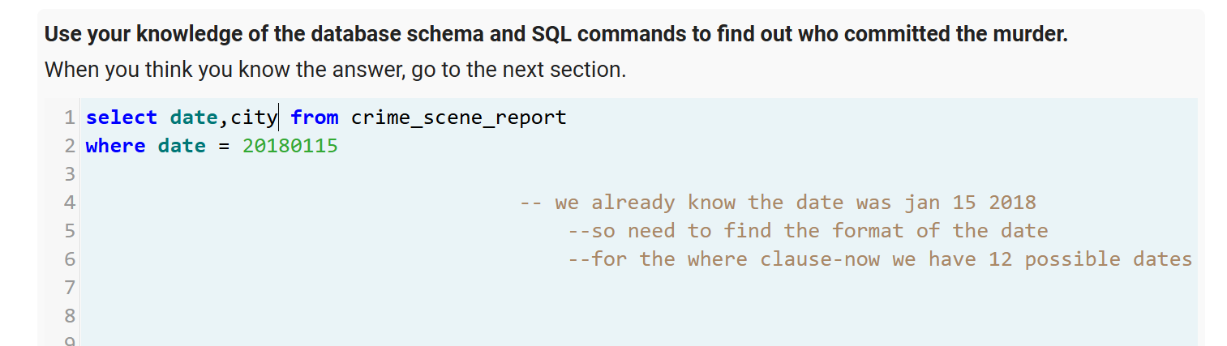

My first though was let’s narrow it down to the date now we have 12 possible dates and my next though was the murder was in SQL city. Let’s see how many murders accrued in sql city during jan 15 2018.

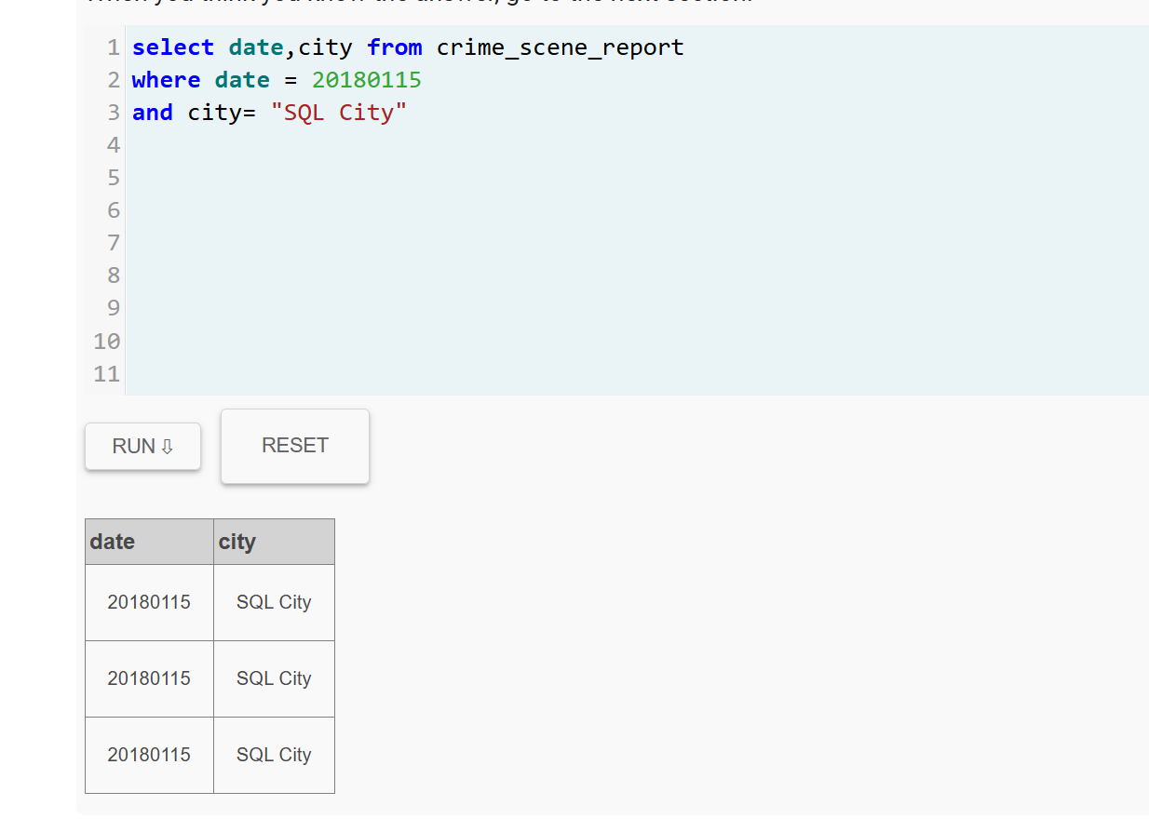
And now we only have 3 possibilities only.

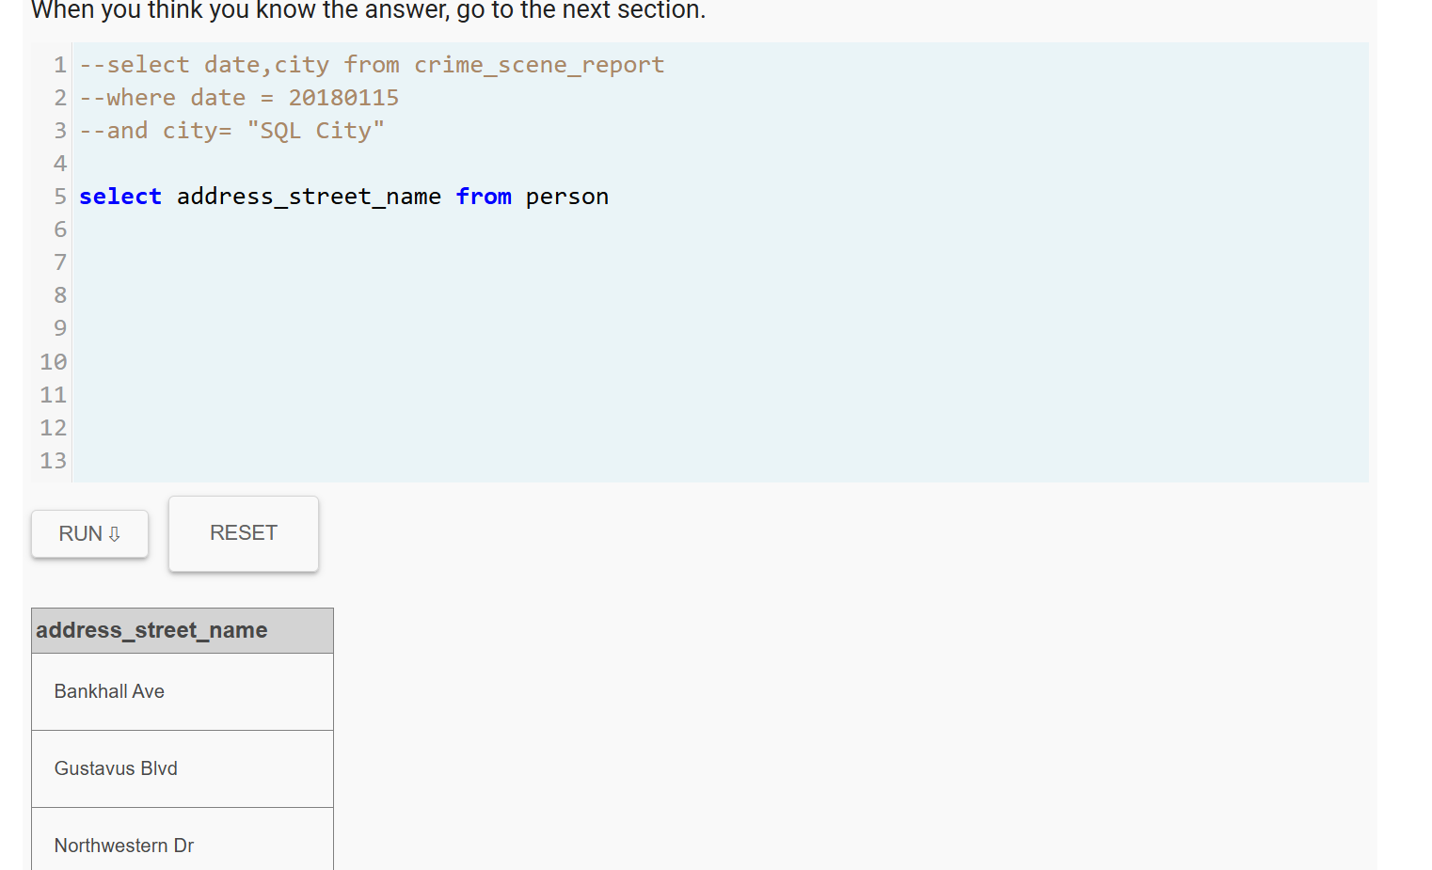

I thought this was going to help me finding the person name who is associated with the sql city but it didn’t. I will just try to see the structure of each table now.

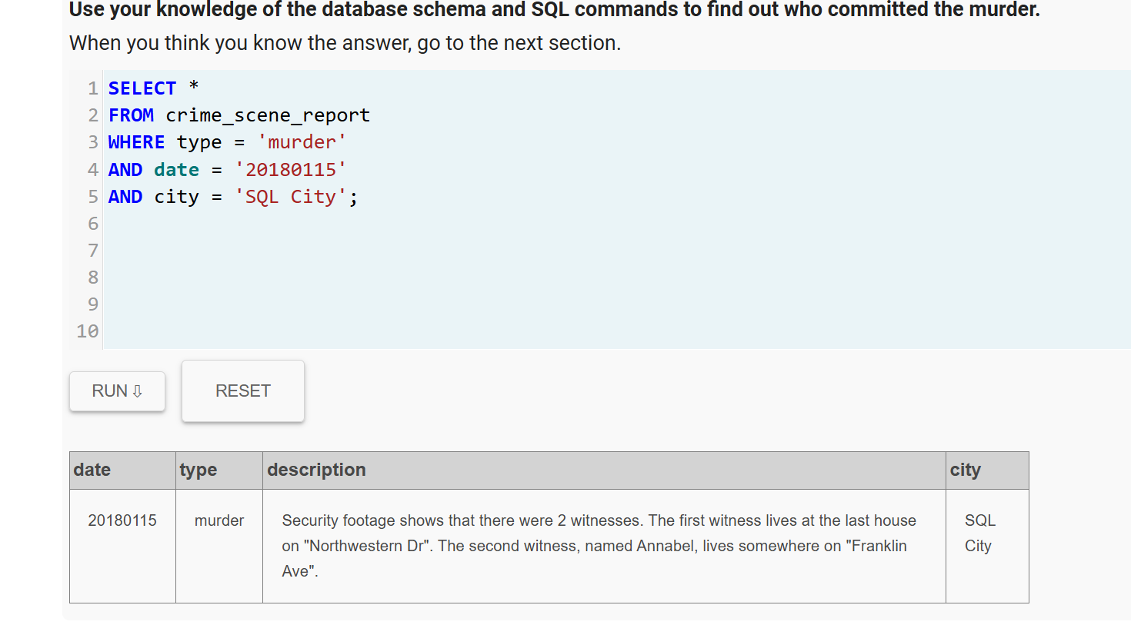

And now we have the description and he hints it provided about the witness
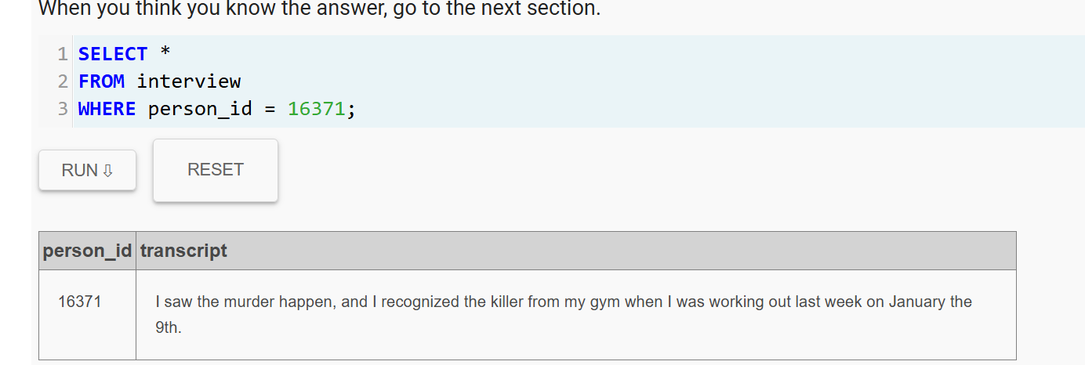

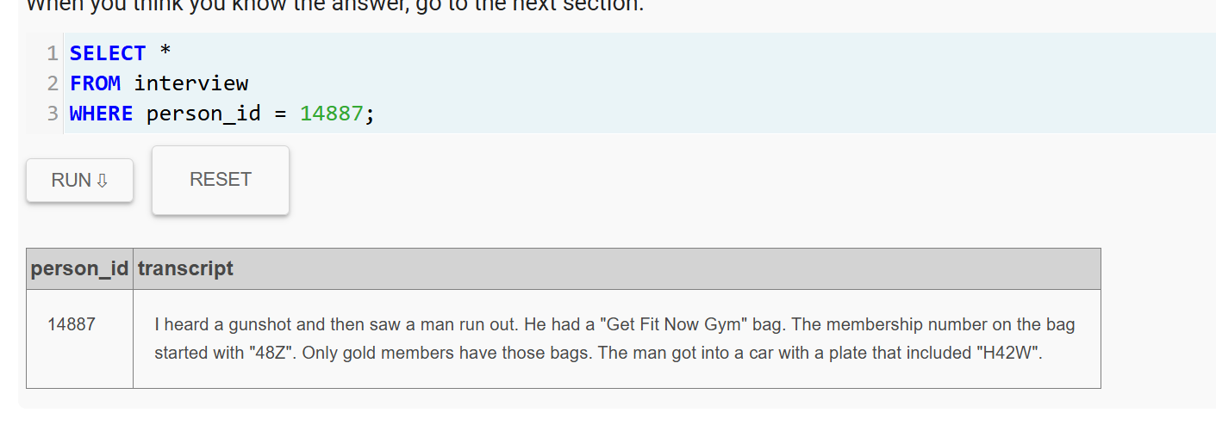
We found their id and this is their statement. We now have to find the gym check in table to see it’s structure

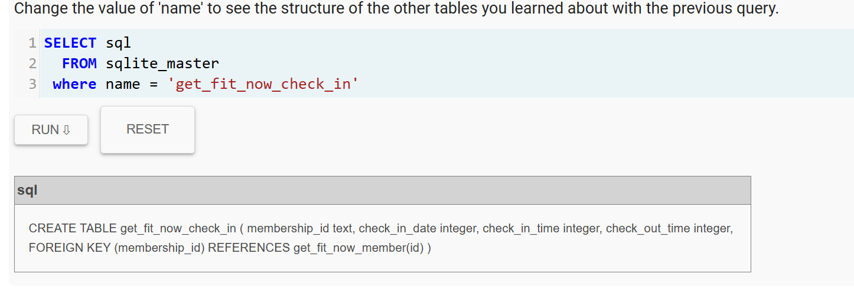

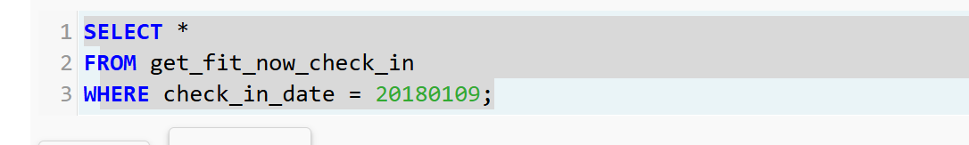
This will give us their membership id for people who checked in jan 9.

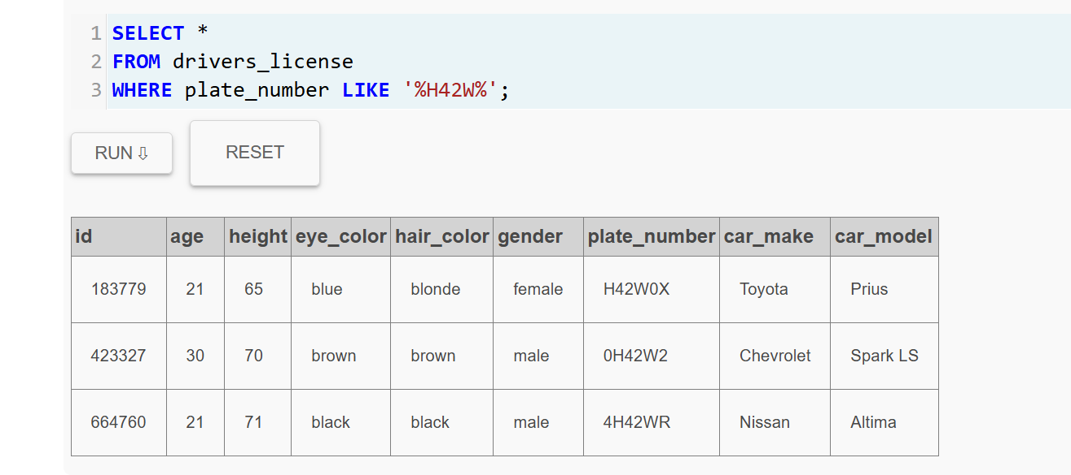
And now we only have 3 suspects. We used the witness descriptions to find the plate number.

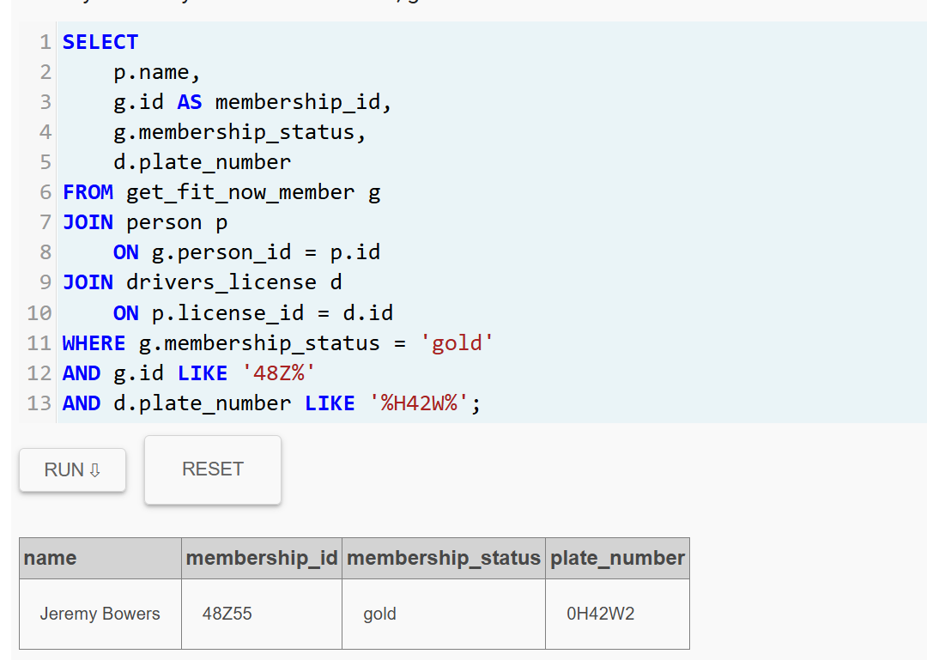

Only one person has gold membership and the play number is what the witness described. And the murder is Jeremy.

